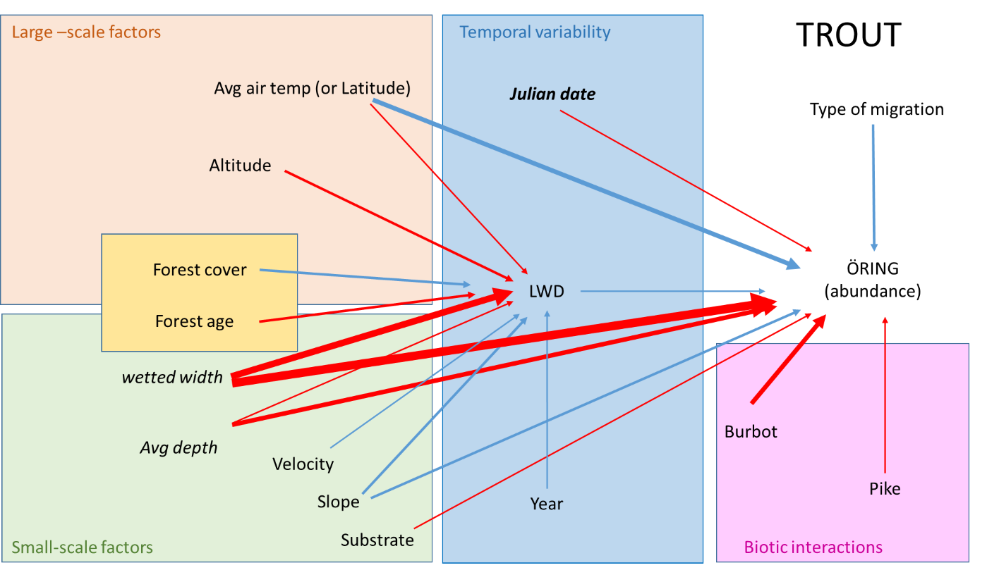

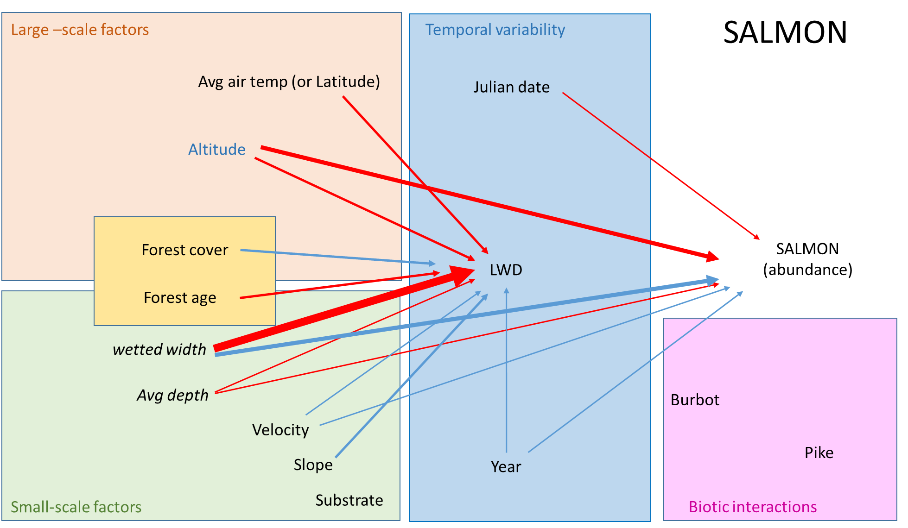

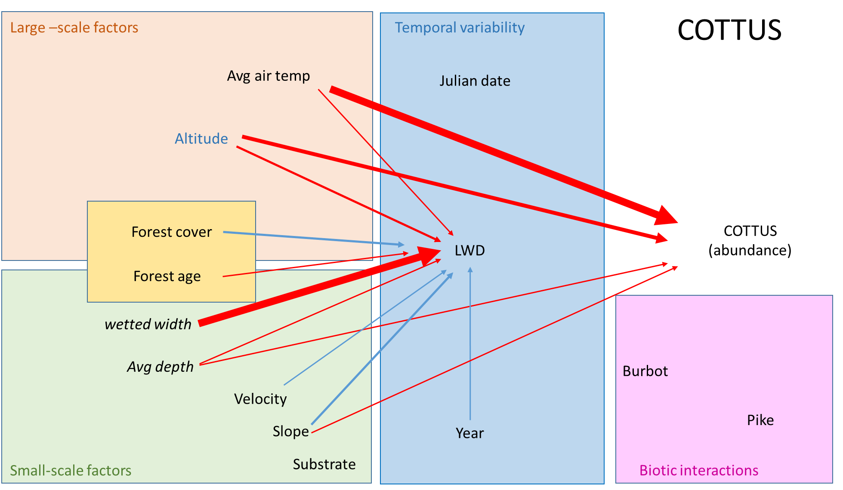

The relative importance of direct and indirect effects of large scale and local factors for stream fish population

Direct and indirect effects of large and small-scale drivers of fish abundance in streams

Dead wood mediates effects of large and small-scale factors on trout abundances

ABSTRACT

Outline

**Introduction**

Fish in streams are important. Fish migrate in rivers and rivers encompass different abiotic and biotic environment. This makes it challenging to identify drivers of fish abundance, and therefore to implement effective restoration measures

We know from existing literature that both local and large-scale factors influence fish abundances/. For example, among large-scale drivers, ….blablabla. On the other hand, variation in small-scale factors diversify habitats in such a way that ../ partition the local environment into different adjacent habitats which are used differently by coexisting (sympatric) species to reduce competition and predation risk. For example…

At local scale, dead wood debris is known to increase fish population growth. However, what species benefit from LWD is not clear yet. Furthermore, we know little about the factors driving LWD abundances and persistence, which limit our ability to use LWD as an effective restoration measure (if conditions are not good for LWD persistence there is little point in adding LWD)

AIMS:

1. Unified framework to understand the relative importance of large-scale and local factors for the abundance of three key fish species in streams
2. Specifically investigate whether local abundance of LWD has beneficial effects on these three species
3. Understanding drivers of LWD persistence

This has important implications from a management perspective.

**Results**

Both large- and local-scale factors affected the abundances of the study fish populations, but their relative importance varied with species (maybe redundant, remove?). Large-scale factors such as year air temperature and altitude mainly explained Cottus abundance (negative effects), while local stream width was the strongest predictor of trout and salmon abundance, showing negative and positive effects respectively. Trout abundance also decreased with stream depth and abundance of the predator turbot, and increased with year air temperature, while salmon abundance decreased with altitude.

LWD appeared to benefit trout but not salmon and Cottus populations. The abundance of LWD strongly decreased with stream width, but also depended, albeit to a less extent, on stream bed slope, forest age and cover, altitude and average air temperature.

**Discussion**

By looking at data it seems like Cottus distribution is mainly determined by large scale factors, while salmonids respond promptly to variation in local conditions. As large-scale drivers typically define the fundamental niche of species, while small-scale factors define the applied niche of species, our results suggest that salmonids may undergo higher competition/predation pressure than Cottus.